12.31: 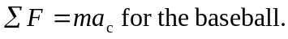
The net force is the gravity force exerted on the baseball by Deimos, so

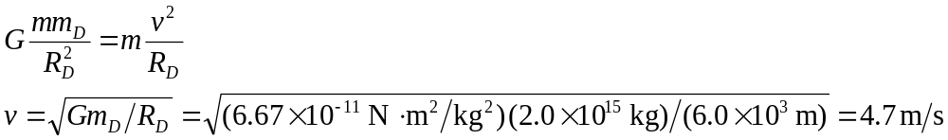
A world-class sprinter runs 100 m in 10 s so have 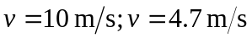 for a thrown baseball is very achieveable.

